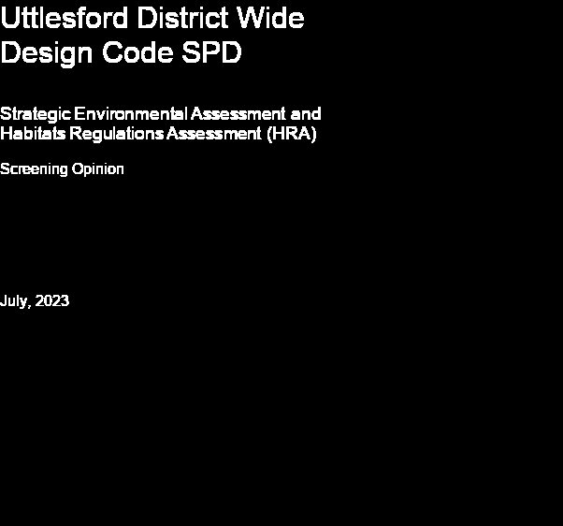
Quality information
Prepared by |  | Checked by |  | Verified by |  | Approved by
Ian McCluskey  Associate Consultant |  | Anthony Whitaker  Principal Consultant |  | Anthony Whitaker  Principal Consultant |  | Anthony Whitaker  Principal Consultant

Revision History
Revision | Revision date | Details | Authorized | Initials | Position
V1 | July 2023 | Draft for internal review |  | IM | Consultant
Final | July 2023 | Final for client |  | IM | Consultant

Prepared for:

Uttlesford District Council

Prepared by:

‌AECOM Limited
aecom.com

© 2023 AECOM Limited. All Rights Reserved.
This document has been prepared by AECOM Limited (“AECOM”) for sole use of our client (the “Client”) in accordance with generally accepted consultancy principles, the budget for fees and the terms of reference agreed between AECOM and the Client. Any information provided by third parties and referred to herein has not been checked or verified by AECOM, unless otherwise expressly stated in the document. No third party may rely upon this document without the prior and express written agreement of AECOM.

Table of Contents
1. Introduction
Background to the District-Wide Design Code SPD
Legislative background
Screening process
2. Assessment
Consideration of significant effects for each of the SEA issues
Biodiversity, flora and fauna
Material Assets, Population and Human health
Soil
Water
Air
Climatic factors
Cultural heritage, including architectural and archaeological heritage
Landscape
3. Conclusions
Consultation
Appendix A: Statutory Body Consultation Responses

Introduction
  - This screening report has been prepared to assist Uttlesford District Council in determining (i.e. screening) the District Wide Design Code Supplementary Planning Document (hereafter referred to as ‘the SPD’).
  - The purpose of screening is to inform the determination process as set out in Regulation 9 of the Environmental Assessment of Plans and Programmes Regulations (2004) – the ‘SEA Regulations’. Regulation 9 requires that the responsible authority determines whether or not a ‘plan’ is likely to have significant effects. Before that determination is made they (the responsible authority) is required to consult the consultation bodies on the decision.
  - This screening report also considers whether the SPD complies with the Habitats Directive (Directive 92/43/ECC) and Birds Directive (Directive 79/409/EEC) (i.e. whether there are likely to be significant effects on the network of European sites).
  - The purpose of this report is to provide the consultation bodies and the local planning authority (LPA) with enough information to make these screening decisions.

Background to the District-Wide Design Code SPD

  - The Design Code is being proposed as a Supplementary Planning Document (SPD) and will apply to development across the entire district of Uttlesford.
  - The SPD forms a material consideration in the determination of planning applications and it should be read in conjunction with the adopted development plan including national policy and guidance.
  - The SPD contains a range of strategic principles relating to different aspects of design. This leads on to specific ‘expectations’ for developments on a range of design issues which mirror the ‘ten characteristics of well-designed places’ as set out within the National Design Guide (see Figure 1-1 below).

Figure 1-1 Ten Characteristics of a well-designed place
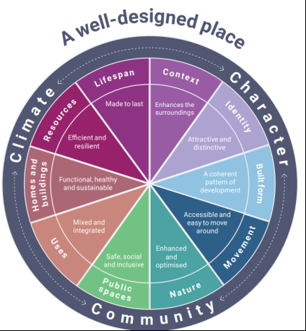

  - The National Planning Policy Guidance (Para 008) states that:
Supplementary planning documents do not require a sustainability appraisal but may in exceptional circumstances require a strategic environmental assessment if they are likely to have significant environmental effects that have not already have been assessed during the preparation of the relevant strategic policies.
  - The current Local Plan for Uttlesford is relatively out-dated, and therefore, the Design Code SPD has been prepared in the context of the National Planning Policy Framework (NPPF), the National Design Code and Guidance and the emerging Local Plan for Uttlesford.
  - The Design Code SPD will also need to be read and applied alongside made Neighbourhood Plans within Uttlesford, each of which sets out policies for specific areas within the district.

Legislative background
  - The Habitats Directive was transposed into English Law by the Conservation (Natural Habitats) Regulations 1994. The Habitats Directive ensures the conservation of a wide range of rare, threatened or endemic animal and plant species and habitat types. There is a requirement to determine whether there are likely to be significant effects on European sites as a result of Neighbourhood Plans. A precautionary approach is necessary when determining likely significance.
  - The SEA Directive has been transposed into English law by the Environmental Assessment of Plans and Programmes Regulations 2004, or the ‘SEA Regulations’.
  - To decide whether a plan is likely to have significant effects on the environment, and hence requires SEA, it should be screened at an early stage, i.e. once the plan remit and objectives have been formulated, at the earliest stage possible.
  - Screening is ‘Stage A’ in the government’s recommended six stage approach to SEA outlined in the NPPG. If it is determined, through screening, that significant environmental effects are unlikely and hence SEA is not required, then further SEA is not required.
  - Regulations 9 and 11 of the SEA Regulations set out the procedure for screening the plan. The steps are summarized below:
- Assess the likely effects of the plan
- Conclude whether the plan requires SEA
- Consult the consultation bodies
- Final determination
- Publicise determination within 28 days.

Screening process
  - The SEA screening process is illustrated in Figure 1-2.
  - As part of the SEA screening process, it is possible to consider implications for HRA purposes in an integrated manner (i.e. by considering HRA implications as part of related topics in the SEA; primarily ‘biodiversity’).
  - The Local Planning Authority, in this case, has commissioned AECOM to undertake the screening opinion on its behalf.

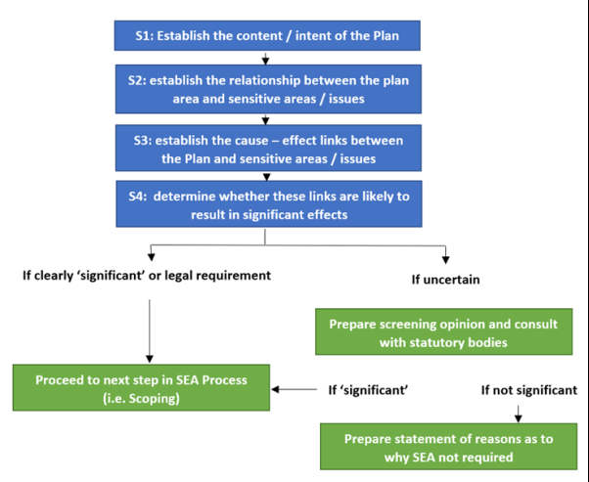
Figure 1-2 SEA screening process

Assessment
  - The content / intent of the SPD is introduced in Section 1, with further detail provided in Table 2-1 below in relation to the SEA Regulations.
Table 2-1 Screening criteria and content of the plan
 | Stage | Comments
1 | Is the Plan subject to preparation and/or adoption by a national, regional or local authority OR prepared by an authority for adoption through a legislative procedure by Parliament or Government? (Art. 2(a)) | Yes. A supplementary planning document is prepared by a local authority and must adhere to the processes and requirements set out within relevant planning regulations.
2 | Is the Plan required by legislative, regulatory or administrative provisions? (Art. 2(a)) | There is no legislative requirement to prepare SPDs. However, the NPPF and proposals within the Levelling Up and Regeneration Bill suggest that Local Authorities should prepare design codes to guide development within their administrations.
3 | Is the Plan prepared for agriculture, forestry, fisheries, energy, industry, transport, waste management, water management, telecommunications, tourism, town and country planning or land use, AND does it set a framework for future development consent of projects in Annexes I and II to the EIA Directive? (Art 3.2(a)) | The SPD is prepared to support town and country planning. Though the plan does not involve making changes to the use of land, it does set out a range of expectations that will need to be taken into consideration (as a material consideration) in the consent of developments (including those that may sit within Annexes I and II of the Directive.
4 | Will the Plan, in view of its likely effect on sites, require an assessment for future development under Article 6 or 7 of the Habitats Directive? (Art. 3.2 (b)) | The scope of the SPD does not involve planning for quantities or types of development that would typically give rise to likely significant effects on European sites.
5 | Does the Plan determine the use of small areas at the local level, OR is it a minor modification of another Plan or Programme (PP) subject to Art. 3.2? (Art. 3.3) | The SPD does not directly determine the use of land, rather it seeks to influence how developments are designed. However, some proposals within the SPD could influence decisions in relation to whether development is appropriate in certain locations. There are also ‘expectations’ of development that will determine land uses – for example, the proportion of green space in new developments.
6 | Does the Plan set the framework for future development consent of projects (not just projects in annexes to the EIA Directive)? (Art 3.4) | Yes. The SPD introduces expectations for all development across Uttlesford and will be a material consideration in the planning-consent process. The current Local Plan is out of date, and the new Plan is yet to be published in draft form.
7 | Is the Plan sole purpose to serve the national defence or civil emergency, OR is it a financial or budget PP, OR is it co-financed by structural funds or EAGGF programmes 2000 to 2006/7? (Art 3.8, 3.9) | No, the plan will not serve the national defence or civil emergency, nor is it a financial or budget PP, OR is it co-financed by structural funds or EAGGF programmes 2000 to 2006/7? (Art 3.8, 3.9)
8 | Is it likely to have a significant effect on the environment? (Art. 3.5) | See assessment section below for further consideration.

Consideration of significant effects for each of the SEA issues
  - Annex 1 of the SEA Directive identifies a number of potential aspects of the environment which may require consideration in relation to significant effects. These issues may include (but are not limited to): “biodiversity, population, human health, fauna, flora, soil, water, air, climatic factors, material assets, cultural heritage including architectural and archaeological heritage, landscape and the interrelationship between the above factors”. The following discussion considers any relevant issues in relation to each of these aspects of the environment and how they might be affected as a result of the proposals of the SPD.
  - In considering the potential for significant effects, note is taken of:
- the sensitivity of ‘receptors’;
- the extent to which the SPD introduces enhanced policy requirements (compared to the current position); and
- the potential for the SPD to affect the amount and distribution of development.

Biodiversity, flora and fauna
  - There are no European Designated sites within Uttlesford. Though design of development can affect biodiversity, it is usually additional growth in particular locations that has the potential for significant effects on European sites. As such, design expectations are unlikely to have any significant effect and a Habitats Regulations Assessment is considered unnecessary.
  - With regards to other designated sites, there are a range of SSSIs, National Nature Reserves and an extensive network of locally important sites. It is unlikely that there would be direct effects upon such assets, as no growth or land use policies are involved in the SPD.
  - The SPD expands upon national design code guidance and reflects policy requirements of the NPPF. For the most part, the expectations in the SPD provide guidance and strong encouragement rather than setting requirements or standards and therefore significant effects are unlikely.
  - For larger developments, it is ‘expected’ that 20% net gain would be achieved. Whilst this could encourage developers to strive to exceed minimum 10% requirements, it is not enforceable through an SPD, so significant effects are not likely / certain in this respect either.
  - For the purposes of SEA, it is concluded that there would be no likely significant effects (either positive or negative).

Material Assets, Population and Human health
  - The SPD does not involve targets for housing or employment growth, nor does it identify land or broad locations for development. In this sense, there are unlikely to be any significant effects with regards to population and human health.
  - The SPD could influence the amount and location of development coming forward in particular locations as it sets out expectations in relation to space standards, housing density and access to services. The expectations in relation to the type and quality of development could have mixed effects. On one hand, the SPD is likely to be positive in relation to health and wellbeing as it should lead to higher quality developments that address a range of factors that can influence health. On the other, there is a large range of ‘requirements’ that could affect housing viability. It is considered unlikely that these effects would be significant though, as there is an expectation that SPDs should not unnecessarily add to the financial burden of developments.
  - It is concluded that given the scope and status of the SPD there are no likely significant effects (either positive or negative). The consideration of housing provision and distribution is being tested through the emerging Local Plan Sustainability Appraisal process.

Soil
  - The district contains a significant amount of Grade 2 agricultural land (over 50,000 hectares), which is considered to be ‘best and most versatile’.
  - However, the SPD will not lead to any change in land use that would affect such resources. There will also be a need to protect soil resources to align with the requirements of the NPPF and Local Plan policy (adopted and emerging).
  - Therefore, it is concluded that there are no likely significant effects (either positive or negative).

Water
  - There are several measures that seek to ensure new developments manage water resources through design. This includes consideration of sustainable drainage, water saving measures and flood management. For example, there is a desire to maximise greywater and rainwater recycling within homes. Whilst these measures are positive, they are not firm policy requirements and therefore, it is considered that there would be no likely significant effects.

Air
  - The SPD will not contribute to an increase in homes or employment, which is when significant effects in relation to air quality typically arise (through the cumulative effects of increased growth). Having said that, the SPD encourages development to be located in accessible locations and sets out a range of expectations for development to be supportive of modal shift (for example, adequate walking and cycling links, appropriate parking standards, space for electric vehicle charge points etc). Whilst these are all likely to contribute positively towards an improvement in air quality over the longer term, it is expected that such measures would need to be addressed to satisfy existing policy. Whilst the SPD will help in the implementation of policy measures to address air quality (and travel), this is not a radical change in policy direction. Therefore, whilst positive effects would be expected, these are not likely to be significant.

Climatic factors
  - With regards to climate change mitigation, the SPD includes a range of measures to drive down carbon emissions, improve energy and water efficiency, minimise embodied carbon, and increase the use of low-carbon energy sources. These are all positive measures, and help to complement national policy and local aspirations for zero carbon lifestyles.
  - Though the wording of the SPD suggests that certain measures will be a ‘must’, it is important to remember that no new policy is being introduced, and therefore these have been viewed as ‘expectations’ rather than firm requirements. In terms of significance, no additional development is being planned for, and new development (which is being addressed through the new Local Plan) will still contribute a relatively limited amount of carbon compared to existing building stock.
  - Given the scope of the SPD, it is concluded that there are no likely significant effects (either positive or negative).

Cultural heritage, including architectural and archaeological heritage
  - Many of the settlements across the district hold significant heritage value, reflected through the large number of historic environment designations of both local and national value. It is therefore considered that the setting of heritage assets are vulnerable to change.
  - The SPD expects development to value heritage, history and culture. It provides design guidance and expectations that should help to guide development so that negative effects on heritage are more likely to be avoided and positive effects achieved. The SPD also seeks to ensure that heritage is taken into consideration in the delivery of other design features, to ensure that high quality developments are compatible with and complement the historic environment.
  - The SPD does not introduce new policy requirements or stray significantly from the existing policy framework provided by the NPPF, national design code and adopted Local Plan. As such, it is considered that there are no likely significant effects (either positive or negative).

Landscape
  - There are no nationally designated landscapes within Uttlesford. However, as a predominantly rural district, the link between settlements and the countryside setting is strong.
  - The SPD does not involve growth and is unlikely to support development in rural locations unless they are of high quality design and take account of landscape context (indeed, this is one of the aims for new development within the SPD). The expectations within the SPD essentially reflect and complement existing policy (national and local), and is unlikely to lead to significant effects on areas of landscape importance. Therefore, whilst positive effects would be expected, these are not likely to be significant.

Conclusions

  - It is concluded that the SPD will have no likely significant effects (either positive or negative) and therefore a full SEA is not required. It is also concluded that the plan will have no likely significant effects on European sites and therefore a HRA is not required.
  - The key factors in determining that significant effects are unlikely are summarised below:
- The SPD has no bearing on the amount of new development that is being planned for in Uttlesford (this is being addressed through an emerging local plan that is being tested through sustainability appraisal and HRA).
- The SPD could have a minor impact upon the distribution of development, as it discourages development in inaccessible locations and deals with aspects such as layout. However, this is unlikely to significantly affect patterns of growth across the district.
- Though there are some sensitive environmental receptors across the district, none are likely to be significantly affected by development design alone.
- The SPD does not set new policy or firm requirements for development (rather, a series of expectations are set out that seek to strongly encourage developers to adopt the principles within the SPD). Therefore, whilst positive effects are considered likely for a range of factors, these are not considered to be significant (in the context of the existing and emerging policy framework).

Consultation
  - Uttlesford District Council, as the responsible authority, have given consideration to this screening opinion and have determined that the SEA and HRA processes do not need to be taken further (i.e. SEA and HRA have been ‘screened out’).
  - The Council is now inviting feedback from the statutory consultation bodies (Natural England, Historic England and the Environment Agency in the case of SEA and Natural England in the case of HRA).
Appendix A: Statutory Body Consultation Responses
To be completed following consultation
aecom.com

